DHM Website Content
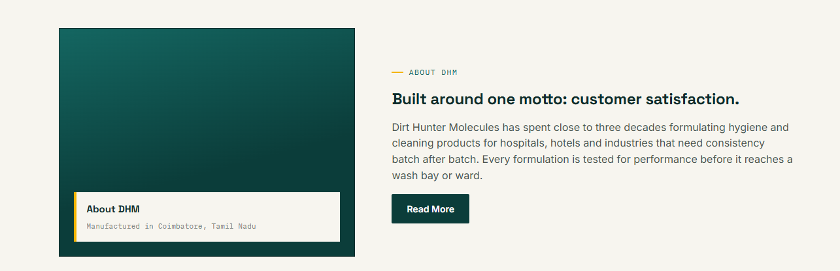
Used This image for about section


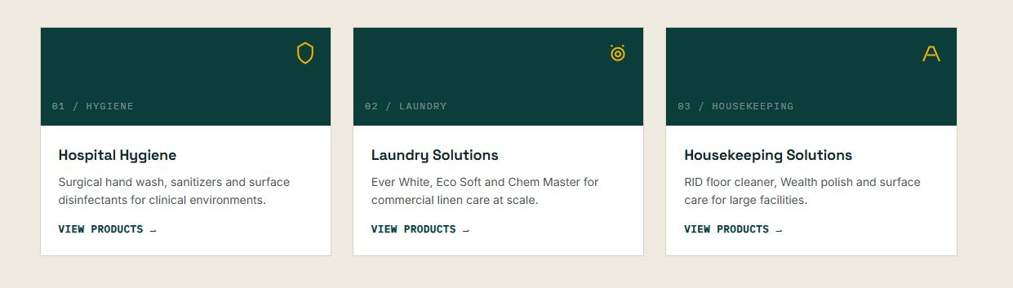

Hospital Hygines
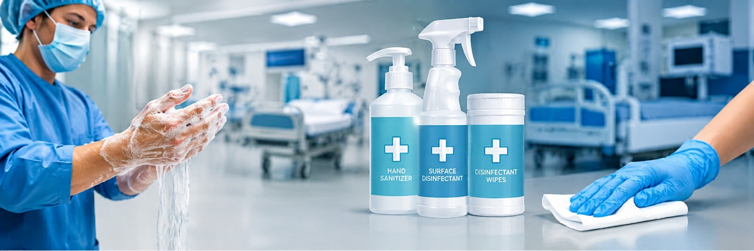
Laundry Solutions
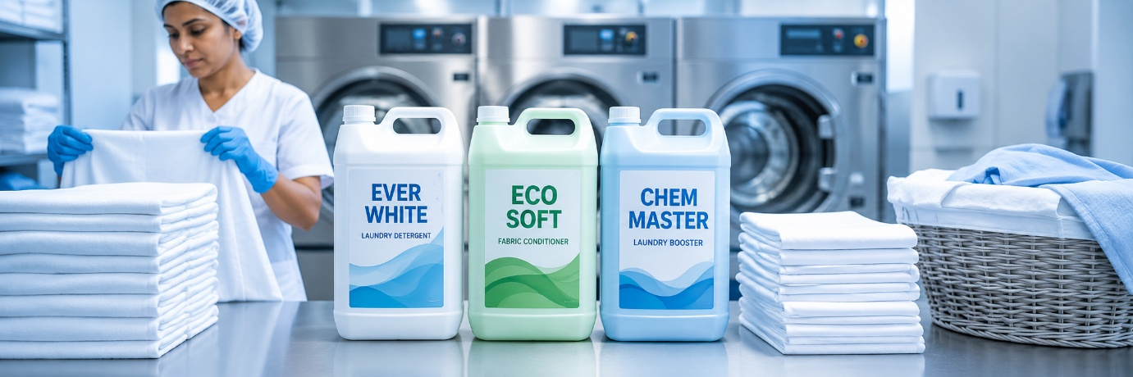
House keeping
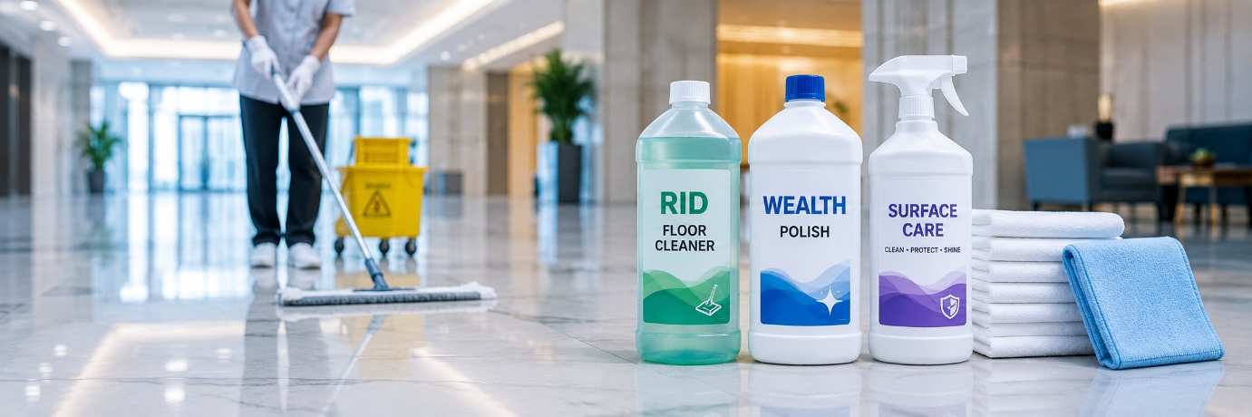

Send this icons in whats up
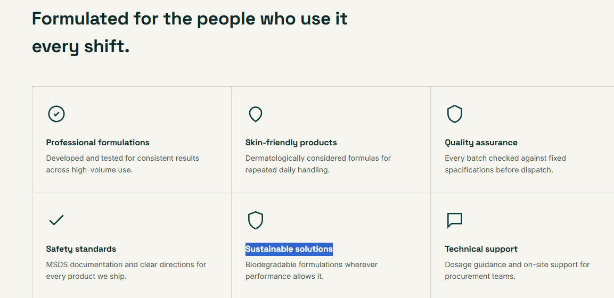
This section image also send whats app
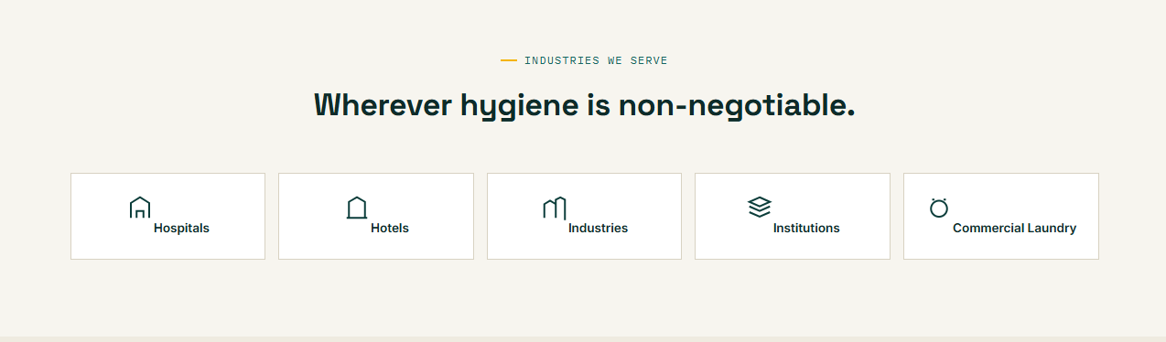
This icon image share whats app
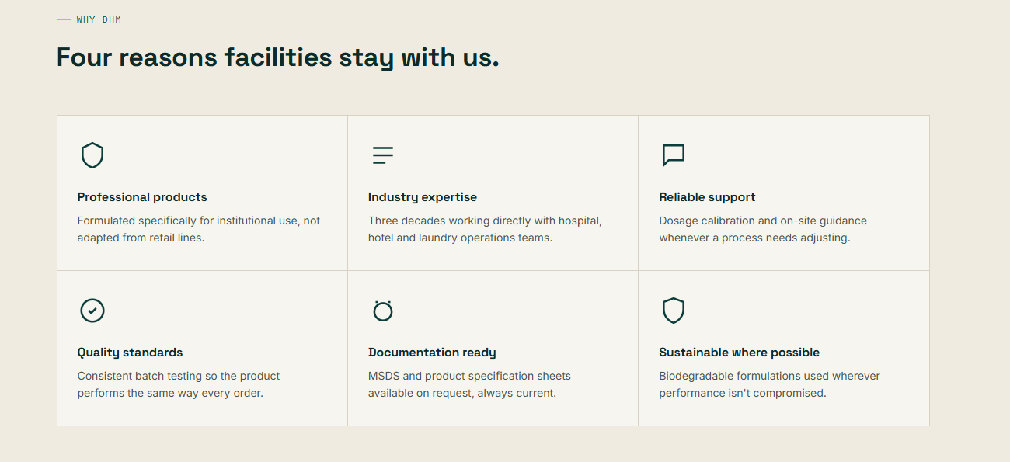
Remove 4 certificate add 3 certificate only
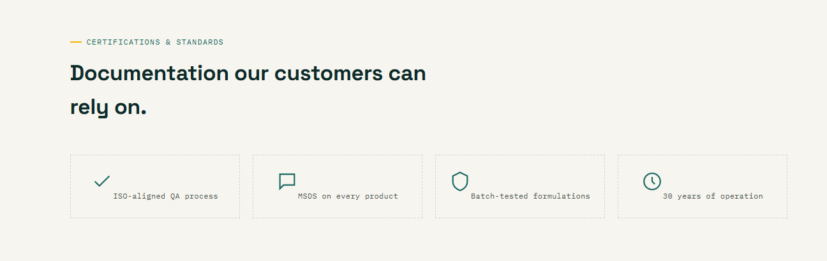
I share whats up in images
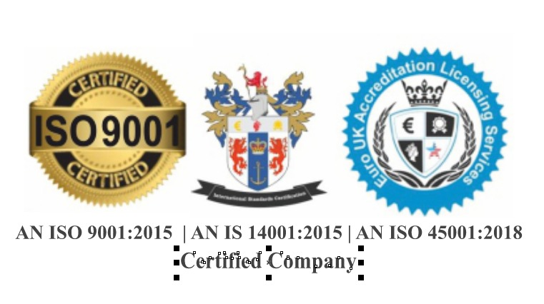
Products
Laundry care
1.Easy wash
2.Ever White
3.Enzyme
4.Eco soft
5.Clorex
6.Vertex
7.Chem Master
8.Sodium hypochlorite

House Keeping
1.safeshield
2.white phenol
3.super shine
4.RID
5.Lemon – on dishwash active gel
6.resolve toilet cleaner
7.REX Disnfected toilet cleaner
8.rescue toilet cleaner
9.maxwell toilet cleaner
10.wealth
11.Deft
12.Enrich room mate

